GIT Ubuntu guide

1. **Git --version**
2. **Git hub access**
   1. **Go to github.com website**
   2. **Create login account or copy your username if already created.**
3. **Git config --global user.name “<Your_username_here>”**
4. **Git config --global user.email “<Your_emailid>@gmail.com”**
5. **Set up GIT HUB CLI**
   1. **Google Search - git hub cli install ubuntu**
   2. **Google Search - linux installation instruction on that page**
   3. **One by one use the commands mentioned below:**

type -p curl >/dev/null || sudo apt install curl -y

curl -fsSL https://cli.github.com/packages/githubcli-archive-keyring.gpg | sudo dd of=/usr/share/keyrings/githubcli-archive-keyring.gpg \

sudo chmod go+r /usr/share/keyrings/githubcli-archive-keyring.gpg \

echo "deb [arch=$(dpkg --print-architecture) signed-by=/usr/share/keyrings/githubcli-archive-keyring.gpg] https://cli.github.com/packages stable main" | sudo tee /etc/apt/sources.list.d/github-cli.list > /dev/null \

sudo apt update \

sudo apt install gh -y

type “gh auth login” on terminal

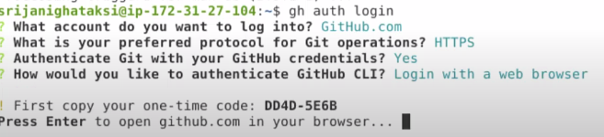

* + 1. when it asks login choose github.com
    2. then choose https
    3. credentials Yes
    4. login with web browser
    5. Enter OTP on device login page which opens up.

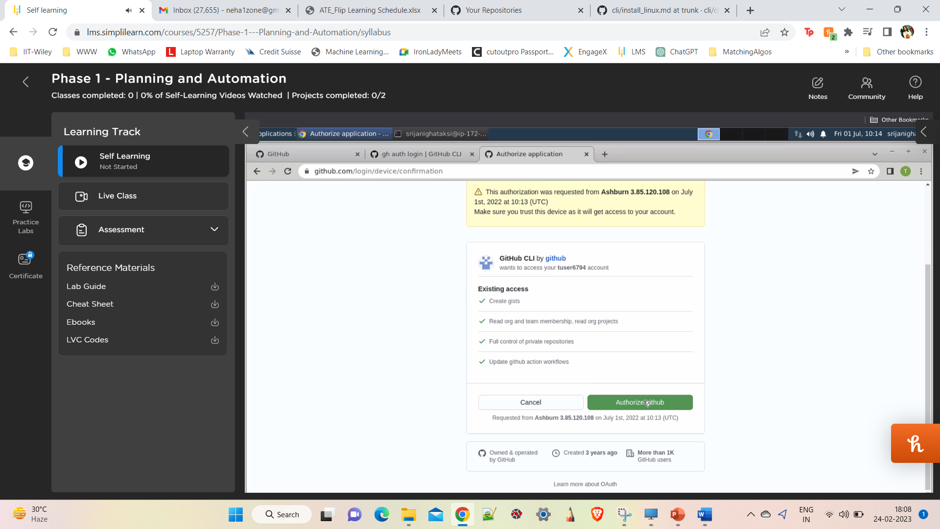

1. Why do we need to do above cli configuration?
2. Git config --list
3. Git init
4. Git remote add origin <https://github.com/nehaasthana0807/Education.git>
5. Git push -u origin master
6. Create a new branch – git checkout -b testbranch
7. Git add . (all)
8. Git commit -m “msg”
9. Git push -u origin master
10. Git branch to check how many branches
11. Git merge branch1 (will merge into current branch)
12. Git push -u origin master branch1